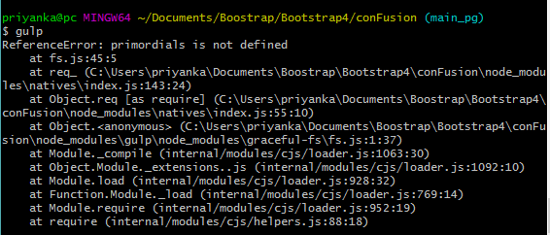

Using [npm-force-resolutions](https://github.com/rogeriochaves/npm-force-resolutions) as a preinstall script, you can obtain a similar result as with yarn v1. You need to modify your package.json this way:

{

// Your current package.json

"scripts": {

// Your current package.json scripts

"preinstall": "npx npm-force-resolutions"

},

"resolutions": {

"graceful-fs": "^4.2.4"

}

}

npm-force-resolutions will alter the package-lock.json file to set graceful-fsto the wanted version before the install is done.